Word document into ODT document:
It is possible to convert a simple word document into ODT document.

Some of the Supported elements are:
- Paragraph
- Tables
- Hyperlink
- Image
Table with Images:
SNO | Product Name | Product Image
1 | Mountain 200 | 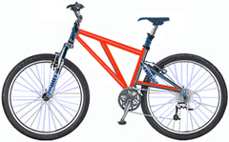
2 | Mountain 300 | 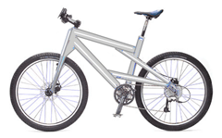
3 | Road 150 | 

